Create a Jenkins container and configure a job to deploy hello world application using multistage docker file

1.Installing Jenkins

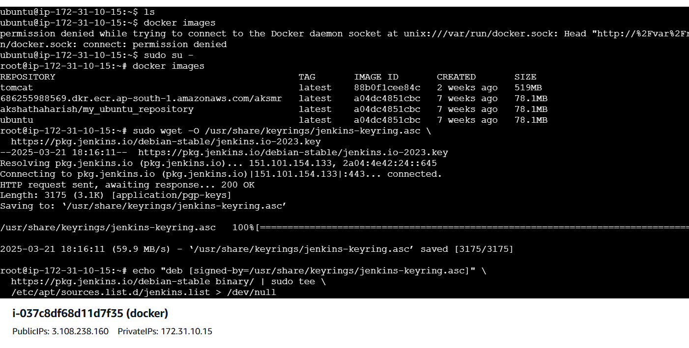

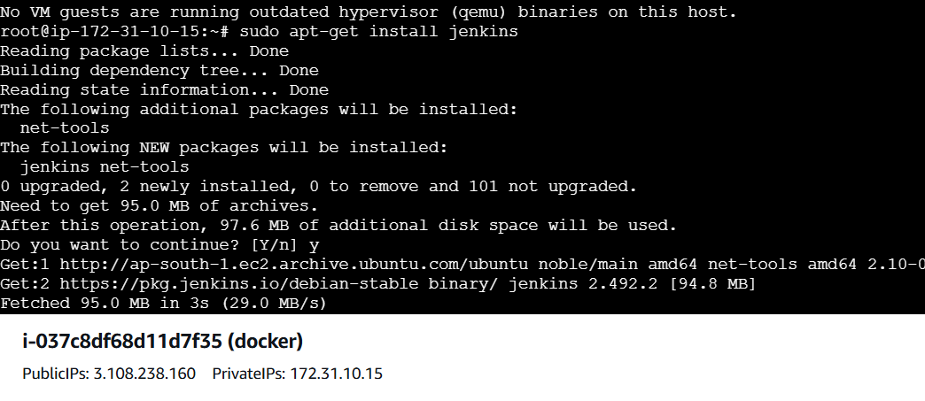

2.Configure the Jenkins and login to Jenkins

3.Install plugins inside Jenkins:

1.Docker Pipeline Plugin

2.Git Plugin

4.Configure Credentials for DockerHub

Go to Jenkins Dashboard → Manage Jenkins → Manage Credentials.

5. Create a New Pipeline Job

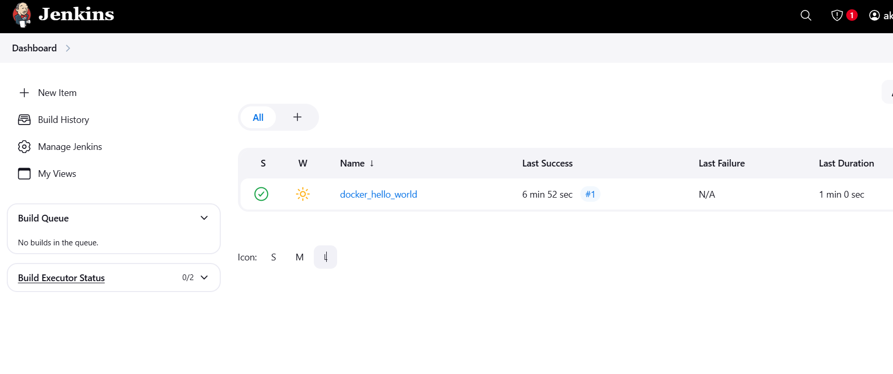

6.Trigger the job

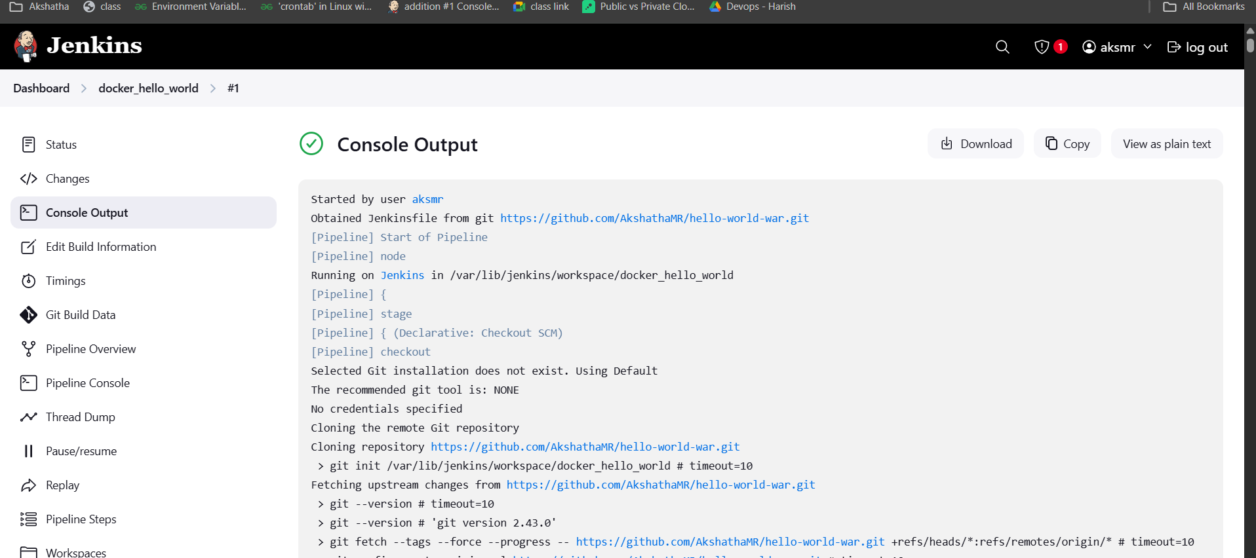

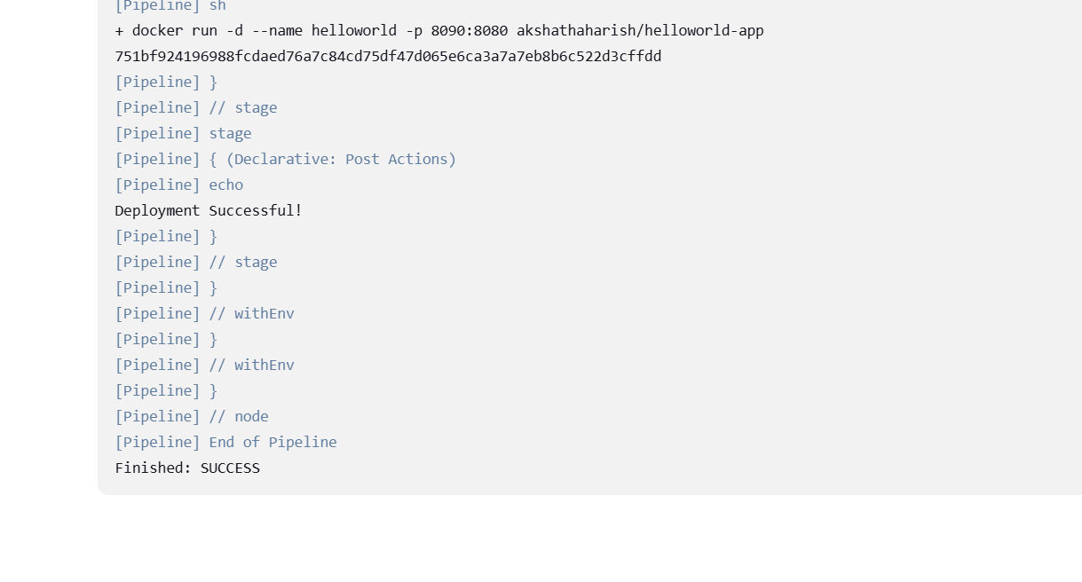

7.Docker Image is uploaded in Docker hub

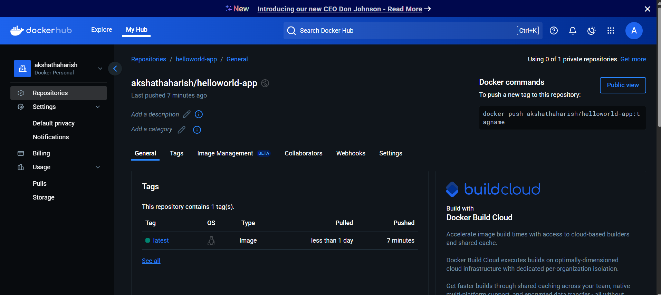

8. Tomcat is up and running, War file copied to webapps folder

<http://3.108.238.160:8090/hello-world-war-1.0.0/>

